# Table of Contents

ABSTRACT. 5

INTRODUCTION. 6

1.1 BACKGROUND OF THE SYSTEM. 6

1.2 OVERVIEW OF THE SYSTEM. 6

1.3 AIMS AND OBJECTIVES. 6

ANALYSIS. 7

2.1 INFORMATION GATHERING. 7

2.2 FEASIBILITY STUDY. 7

2.3 ANALYSIS METHODOLOGY. 8

2.4 SYSTEM REQUIREMENT SPECIFICATION (SRS). 9

2.4.1 REQUIREMENT ANALYSIS. 9

2.4.1.1 FUNCTIONAL REQUIREMENT. 9

2.4.1.2 NON-FUNCTIONAL REQUIREMENT. 11

2.4.1.3 MoSCoW Prioritization. 12

2.4.2 SOFTWARE AND HARDWARE REQUIREMENT. 13

2.5 SYSTEM ARCHITECTURE. 14

2.6 USE CASE DIAGRAM. 15

2.7 NATURAL LANGUAGE ANALYSIS (NLA). 16

2.8 CLASS DIAGRAM. 17

DESIGN. 18

3.1 INTRODUCTION. 18

3.2 TYPES OF DESIGN. 18

3.2.1 STRUCTURAL DESIGN. 18

3.2.1.1 CLASS DIAGRAM. 18

3.2.1.2 FLOWCHART. 20

3.2.2 BEHAVIORAL DIAGRAM. 21

3.2.2.1 ACTIVITY DIAGRAM. 21

3.2.2.2 SEQUENCE DIAGRAM. 22

3.2.3 DATABASE DESIGN. 23

3.2.3.1 DATA DICTIONARY. 23

3.2.3.2 ER DIAGRAM. 26

3.2.4 UI DESIGN. 26

CODING. 31

4.1 INTRODUCTION. 31

4.2 CODING METHODOLOGY. 31

TESTING 32

5.1 Introduction. 32

5.2 Importance of Testing. 32

5.3 Types of Testing. 32

OTHER PROJECT ISSUES. 48

6.1 PROBLEMS DURING PROJECT. 48

6.2 LIMITATION OF THE PROJECT. 48

6.3 RISK MANAGEMENT. 49

6.4 CONFIGURATION MANAGEMENT. 50

6.5 FUTURE WORK. 50

CONCLUSION. 51

CODE APPENDIX. 52

USER MANUAL. 67

# Table of Figures.

Figure 1:SWOT analysis. 8

Figure 2:3-tier architecture. 14

Figure 3:System Use case diagram. 15

Figure 4:Admin Use case diagram. 16

Figure 5:initial class diagram. 17

Figure 6:Final class diagram. 19

Figure 7:Flowchart. 20

Figure 8:Activity Diagram. 21

Figure 9:Sequence diagram 22

Figure 10:Sequence diagram for admin login. 23

Figure 11:ER diagram. 26

Figure 12:Admin prototype. 27

Figure 13: dashboard prototype 27

Figure 14:category UI 28

Figure 15:Add category UI 29

Figure 16:home page UI 30

Figure 17:Test Admin register 33

Figure 18:test login 34

Figure 19:add category test 35

Figure 20:delete category test 36

Figure 21:add news test 37

Figure 22:delete news test 39

Figure 23:email validation test 39

Figure 24:logging out from dashboard 41

Figure 25:profile update 42

Figure 26:update test 44

Figure 27:logintest 45

Figure 28:registration test 46

Figure 29:delete test 47

Figure 30:configuration of folders 50

Figure 31:header code. 52

Figure 32:footer code, 53

Figure 33:News code. 54

Figure 34:admin login code. 58

Figure 35:category code. 59

Figure 36:dashboard code. 61

Figure 37:database connection. 61

Figure 38:logout code. 62

Figure 39:profile update code. 62

Figure 40:Register user code. 64

Figure 41:Home page code. 65

Figure 42:Admin login. 67

Figure 43:News addition. 69

Figure 44:Category addition. 71

Figure 45:edit category. 72

Figure 46:delete category. 73

Figure 47:Edit News. 73

Figure 48: delete news. 74

Figure 49:update user profile. 75

Figure 50:Logout. 75

# ABSTRACT.

This news portal that I have made has a dedicated area for presenting each of the information related to environment in the page. It provides access to all of the online information related to environment. The main purpose of developing this website is to reduce the time we take on reading newspapers and also reduce the use of papers that promotes green IT concept. Not only this but its aim is also to make this kind of website that is user-friendly. As users use the anchor site portals are the first thing that a browser opens up. In this report I have included all the necessary parts for news portal including design and requirement analysis, testing etc. News creates a new environment of viewing the news through tools.

# INTRODUCTION.

In today’s context, there may rarely be someone who has free time. The project I am working on is an Online News Portal. Nowadays, we live in age of Information Communication and Technology. We can’t even think a single moment without technology. From morning to night, we need help of technology. Most of the works depends upon web application. This news portal will save the time of users in this busy world and helps them to improve their awareness.

## 1.1 BACKGROUND OF THE SYSTEM.

In this busy phase of life, it is hard to manage time to read newspaper. We have to buy one and read it whenever we have time, this not only takes more time but also wastes the paper.

But with the development in part of technology, we will also have to develop by creating the habit of reading news online. This not only saves time but also saves our money as we can read them freely in any site. This news portal will provide up-to-date information addressing every needs of users that include different categories.

To develop this application, I have chosen php Laravel framework that follows MVC pattern and I will also be using PHP, HTML, CSS, JavaScript etc. and will be using MYSQL for database.

## 1.2 OVERVIEW OF THE SYSTEM.

So, in this project I have made an effort to develop a News or Information based website. Various methodologies have been used to develop this website. I have used PHP to develop this website along with the use of HTML, CSS, JavaScript etc. To use and to perform it becomes more easier by UI of the application. It consists of an admin login page, registry page as well as it consists of dashboard. The admin of this page is able to add, edit and delete news, category etc.

## 1.3 AIMS AND OBJECTIVES.

The aims of this project are:

* To save time of users so that they don’t have to wait for newspaper every morning.
* By the use of algorithm and database, news categories shall be uploaded.

The objectives of this project are:

* To develop the website that can aware people.
* People can get information through internet at a low cost in a daily basis.

# ANALYSIS.

Studying something in detail is called analysis. At the beginning of the project analysis was done and requirements are gathered. Analysis helps in determining what the needs of stakeholders are and it also helps in communicating with the stakeholders. It is one of the most important phases in software development life cycle.

## 2.1 INFORMATION GATHERING.

There are different information gathering techniques for a project and they are questionnaire, interviews, focus groups, observation etc. These techniques are used to gather required information from clients.

For the result, I have chosen questionnaire and interview for gathering information in this project. So basically, what is did was distributing questionnaires and conducting both one to one as well as group interviews so that better results could be obtained. And the result was as expected.

## 2.2 FEASIBILITY STUDY.

Feasibility study determines whether a project is socially, economically, technically and legally feasible or not. Cost benefit analysis is also undertaken to find out that whether a project is cost effective or not. It is also done to find out the positive and negative impacts on a project. Feasibility study are of different types and they are:

* Technical Feasibility.

Technical feasibility determines if a project is technically feasible to run or not. This project focuses on various factors such as resources used technically for the project, process and procedures of project etc.

* Economic Feasibility.

This web application is economically feasible because one does not need much money to use this news portal. This portal addresses financial state and assign the resources.

* Legal Feasibility.

As per my study this project does not violate any law and does not create conflict. And hence the project is feasible legally.

* Scheduling Feasibility.

For this project proper time estimation is done and the project will be completed as the given time. So, the scheduling is feasible.

* Social Feasibility.

This project does not hamper and affect any of social factor. And the application is completely based on social factors. So, the portal is socially feasible.

# 2.3 ANALYSIS METHODOLOGY.

Today is the world of technology, web applications are being mostly used. For the web applications, information’s are gathered from web rather than going from person to person and gathering information. For this project, I have used SWOT analysis. SWOT analysis is one of easy way to collect the information.

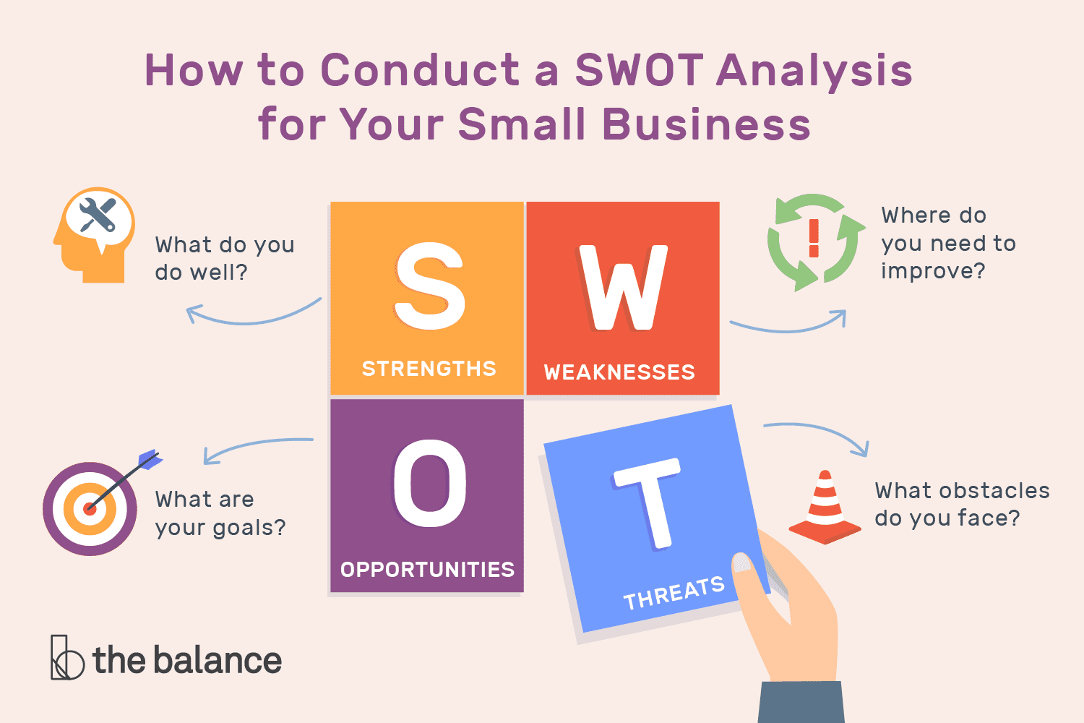

Figure :SWOT analysis.

SWOT stands for Strength, Weakness, Opportunities and Threat. I have used this method because this analysis method helps to identify and understand key issues in our project. But we should be aware that this method has both benefits as well as limitation.

**S**trength: these are the one that are under our control.

**W**eakness: these need to be improved in order to be competitive.

**O**pportunities: they contribute to our success.

**T**hreats: we need to be aware of these.

# 2.4 SYSTEM REQUIREMENT SPECIFICATION (SRS).

System requirement specification is the description of the project that we are developing. The analysis of functional and non-functional requirement is included in this part. This creates a list of documents that is necessary for this project and these documents can be achieved through constant communication with the clients.

## 2.4.1 REQUIREMENT ANALYSIS.

Requirement analysis is the process that determines the user expectations for the application to be built. It also helps us to identify the important stakeholders. For the success of a project it is important to identify the requirements at the starting of project and throughout the project. For gathering the requirement, I have used questionnaire and interviews that helped to gather requirement.

The requirement that we are performing for this project are functional and non-functional.

## 2.4.1.1 FUNCTIONAL REQUIREMENT.

These are the basic requirements that a system must perform. They specify function and behavior of the system. It includes various factors such as data manipulation and processing, calculation etc. that a system is supposed to do.

|  |  |  |  |  |
| --- | --- | --- | --- | --- |
| Function ID | Title | Description | Purpose | Impact  (MoSCoW) |
| F1 | Registration | Admin of the page registers if he/she is new so that they can login later | To use the features of a system. | Must have |
| F2 | Login | Registered users can login to the system. | To access the system in a safe way. | Must have |
| F3 | Comment | Anyone can present their point of view to certain news. | To present a person’s point of view. | Should have |
| F4 | Forum | Medium where ideas and vies can be exchanged. | To exchange ideas with others. | Should have |
| F5 | Search Post | Allows to search for previous posts. | To search post. | Must have |
| F6 | Post Blog | Describes about certain issues. | To write about issues. | Should have |
| F7 | News edit | Allows admin to edit news. | To edit news. | Must Have |
| F8 | Social media interaction. | Can spread news to those who don’t read news. | To spread news to all people. | Must have |
| F9 | Delete news. | News is deleted after it is time up. | To delete news after it is time up | Should have |
| F10 | Dashboard | After login is successful dashboard is displayed. | Admin Dashboard. | Must have. |
| F11 | Profile edit | Admin update their data | Data is modified. | Must have |
| F12 | Add News | Allows admin to add news. | News is added | Must have |
| F13 | List News | List out the recently added news. | Show the list of news. | Must have. |
| F14 | Add category | Allows admin to add category. | Category added. | Must have |
| F15 | Edit category | Allows admin to edit category. | Category updated. | Must have |
| F16 | Delete category | Allows admin to delete category. | Category deleted. | Must have |
| F17 | Logout | Admin logs out after work done. | Logout. | Must have. |

## 2.4.1.2 NON-FUNCTIONAL REQUIREMENT.

Those requirements that shows how the system performs certain function is called non-functional requirement. They are concerned with the quality characteristics rather than specific behavior of the system. Though these requirements do not play important roles but the system will not be considered good without these requirements.

|  |  |  |  |  |
| --- | --- | --- | --- | --- |
| ID | Title | Description | Purpose | Prioritization. |
| NFR01 | Security | How secure the system is | Make sure the login system is secure. | Should have |
| NFR02 | User-friendly UI | How easy UI is | Create easy UI | Should have |
| NFR03 | Data Integrity | How is data manipulated | To make sure it is easy to manipulate data | Could have |
| NFR04 | Reliability | How system is reliable to perform functions. | For the reliability of system. | Could have |
| NFR05 | Safety | How safe the system is and does not harm | To ensure system safety | Could have |
| NFR06 | Durability | How durable the used system is | To make the system last long | Should have |
| NFR07 | Performance | How the system is performing | To increase system performance | Could have |
| NFR08 | Availability | Is the system available any time? | Make sure system has availability every time. | Should have |
| NFR09 | Portability | How portable is the system compared to others? | To use system in various platforms. | Could have |
| NFR10 | Efficiency | What is handling capacity of system. | Make system efficient. | Should have |

## 2.4.1.3 MoSCoW Prioritization.

With prioritization we can differentiate which are the most important and which are the least. People mostly rethink about the requirement after prioritization. Prioritization can help us to determine what to put in each release of software if our product is developing in increment. MoSCoW is a prioritization technique that was originated from DSDM. We can categorize the requirement in following groups:

* Must have: these are the compulsory requirement and project shall fail without it.
* Should have: these are the requirement that inhabit second place in list.
* Could have: these requirements can be removed if they are having risk.
* Won’t have: these requirements will not be included and does not affect the success of project.

**Functional Requirement**

|  |  |  |
| --- | --- | --- |
| ID | Functional requirement | Priority |
| F1 | Registration | Must Have |
| F2 | Login | Must Have |
| F3 | Comment | Should Have |
| F4 | Forum | Should Have |
| F5 | Search Post | Must Have |
| F6 | Post Blog | Should Have |
| F7 | Advertisement | Must Have |
| F8 | Social Media interaction | Must Have |
| F9 | Delete | Should Have |

|  |  |  |
| --- | --- | --- |
| F10 | Dashboard | Must have. |
| F11 | Profile edit | Must have |
| F12 | Add News | Must have |
| F13 | List News | Must have. |
| F14 | Add category | Must have |
| F15 | Edit category | Must have |
| F16 | Delete category | Must have |
| F17 | Logout | Must have. |

**Non-functional Requirement**

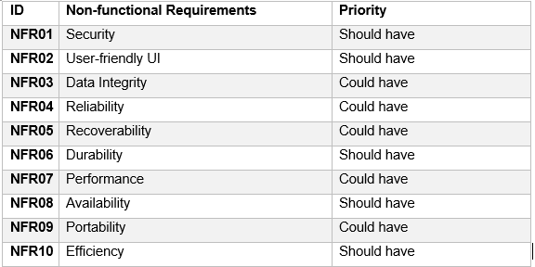

## 2.4.2 SOFTWARE AND HARDWARE REQUIREMENT.

Specification of hardware and software required for the project to run is hardware and software requirement. My project Online News Portal is a small project and it does not require more specifications. Following are the specifications required for my project.

Software Requirement.

**Programming Language:** PHP.

**Database:** My SQL.

**UI Design:** HTML, AJAX, JQUERY, JAVASCRIPT, BOOTSTRAP.

**Web Browser:** Mozilla, Google Chrome/Other compatible browsers.

**Software Used:** XAMPP Server.

Hardware Requirement.

**Operating System:** Windows 8/10 pro

**RAM:** 512 MB

**Processor:** i5

**Space:** 1 GB

## 2.5 SYSTEM ARCHITECTURE.

System architecture is a conceptual model that describes the hardware and software components and their interaction. It defines structure, behavior and views of a system. different decisions can be made on the basis of different factors and these impacts can be seen on overall success of project including maintainability, quality etc.

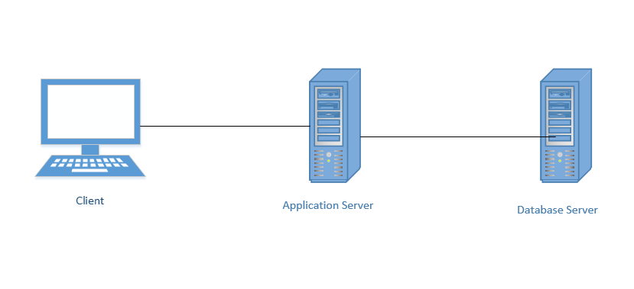

Figure :3-tier architecture.

I have used 3-tier structure for this project. This structure makes logical separation between presentation layer, business logic layer and database layer. It is secure, easily understandable and highly manageable and also adds reliability of original services. So, this will be a good choice for my project.

## 2.6 USE CASE DIAGRAM.

Use case diagram is a graphical representation of the elements that are involved in a system. It shows the relationship between different features of a system along with the actors involved.

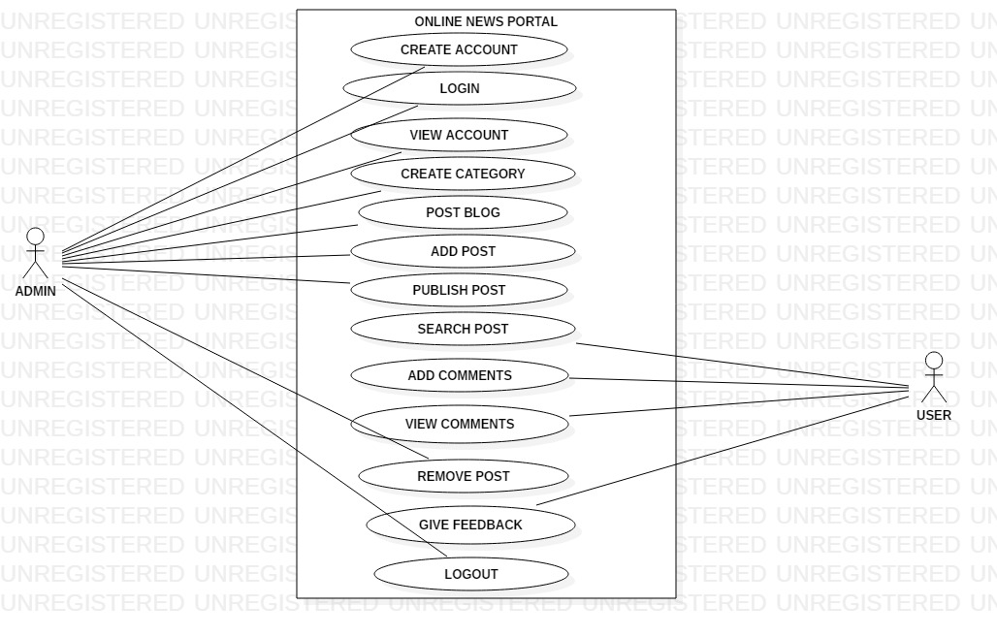

Figure :System Use case diagram.

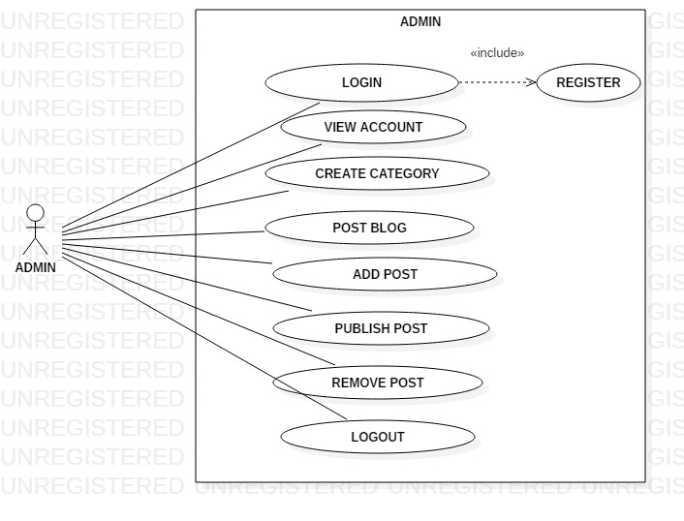

Figure :Admin Use case diagram.

## 2.7 NATURAL LANGUAGE ANALYSIS (NLA).

NLA is the easy process of identifying the possible classes, their attribute, operations through selected nouns, verbs etc. NLA is easy to learn and understand so, it also shows the relation between the classes. The NLA for the system is given below.

|  |  |
| --- | --- |
| Noun | Verb |
| User, Admin, News, Category, Latest Post, Register, Report. | Add, Edit, Search, Delete, Assign. |

Possible candidate class are:

|  |
| --- |
| Possible class. |
| User, Admin, News, Category, Latest Post. |

## 2.8 CLASS DIAGRAM.

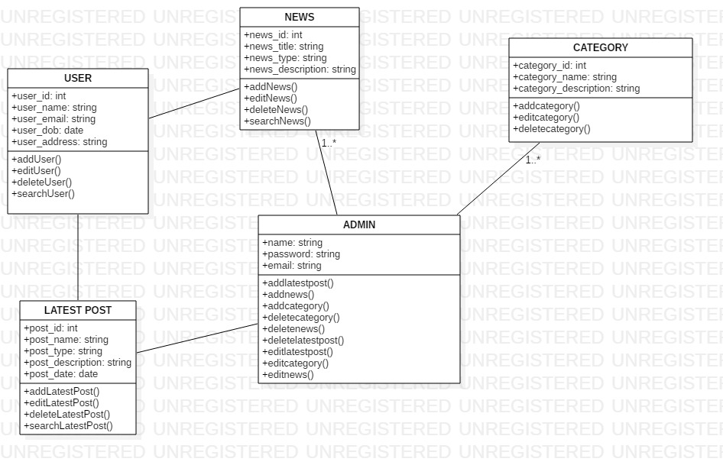

Figure :initial class diagram.

# DESIGN.

## 3.1 INTRODUCTION.

In the system development life cycle, design phase is done after the analysis phase. In the design phase, every idea generated is transformed to diagram and real work. Design is done according to the analysis and user requirement analysis.

## 3.2 TYPES OF DESIGN.

There are 3 types of design and they are creational, structural, and behavioral design. Among these 3 here in this project we will discuss about two types structural and behavioral.

## 3.2.1 STRUCTURAL DESIGN.

Structural design shows the static aspect of the system to be represented. Structural diagram provides ideas on how different modules are interrelated to each other. Class diagram is one of the structural diagrams that is shown below:

## 3.2.1.1 CLASS DIAGRAM.

Class diagram is a diagrammatic representation of the candidate classes and their relationship. Class diagram highlights the attributes, operation, classes and maps out the relation between them.

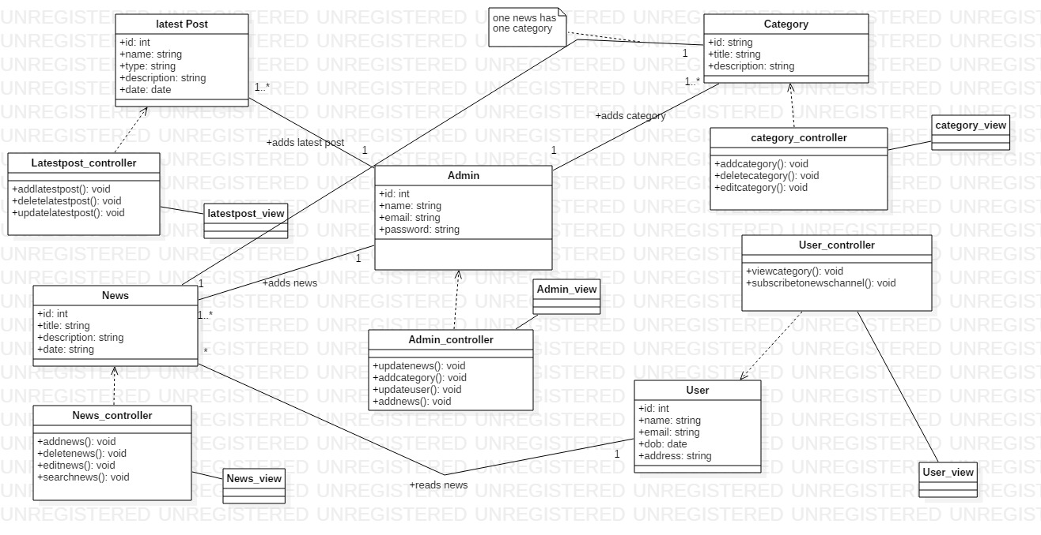

Figure :Final class diagram.

## 3.2.1.2 FLOWCHART.

A flowchart is a diagram that shows the process, system or algorithm. Flowcharts can range from hand-drawn, simple to computerized diagram.

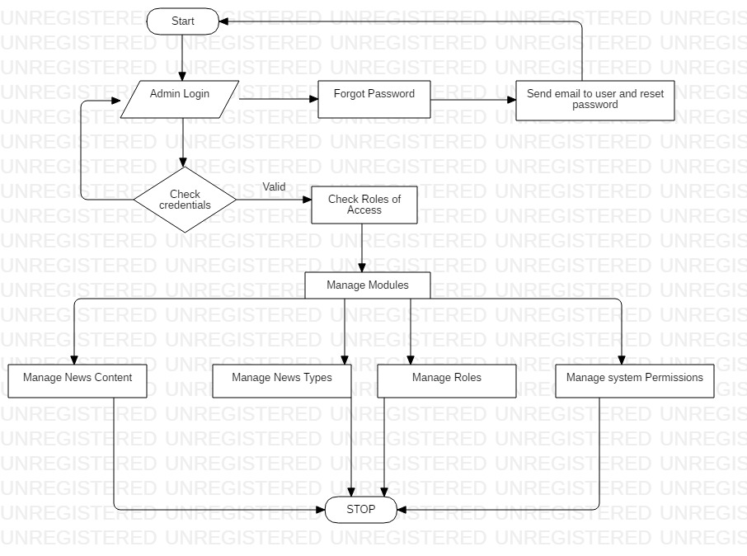

Figure :Flowchart.

## 3.2.2 BEHAVIORAL DIAGRAM.

Behavioral diagram shows the dynamic state of a structure during its execution. It shows what a system does and what happens when system will respond to it.

Here we will be discussing about activity diagram and sequence diagram.

## 3.2.2.1 ACTIVITY DIAGRAM.

Activity diagram is basically a flowchart to represent the flow from one activity to another activity. It captures the dynamic behavior of system and describes the operation.

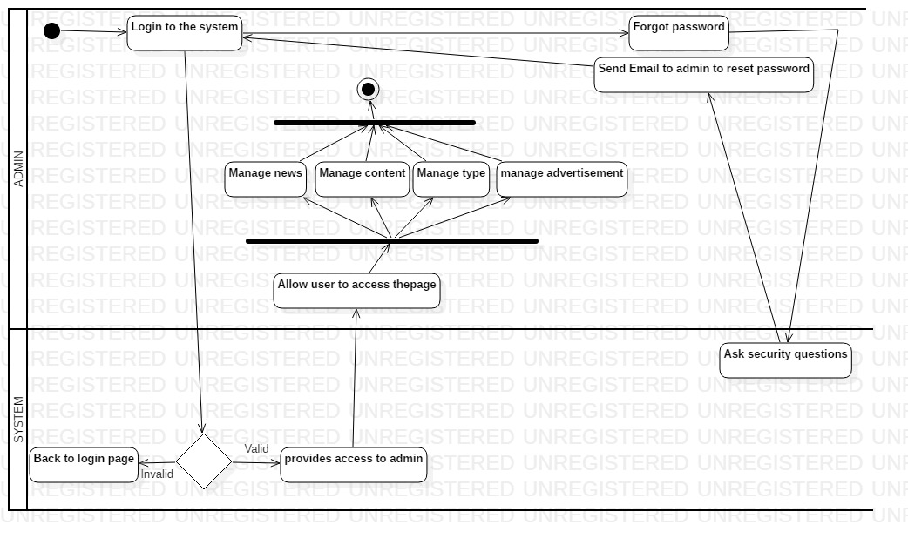

Figure :Activity Diagram.

## 3.2.2.2 SEQUENCE DIAGRAM.

Sequence diagram shows the interaction between classes. This is also called event diagram because it also shows the event. Behavior of the system can be described by this diagram.

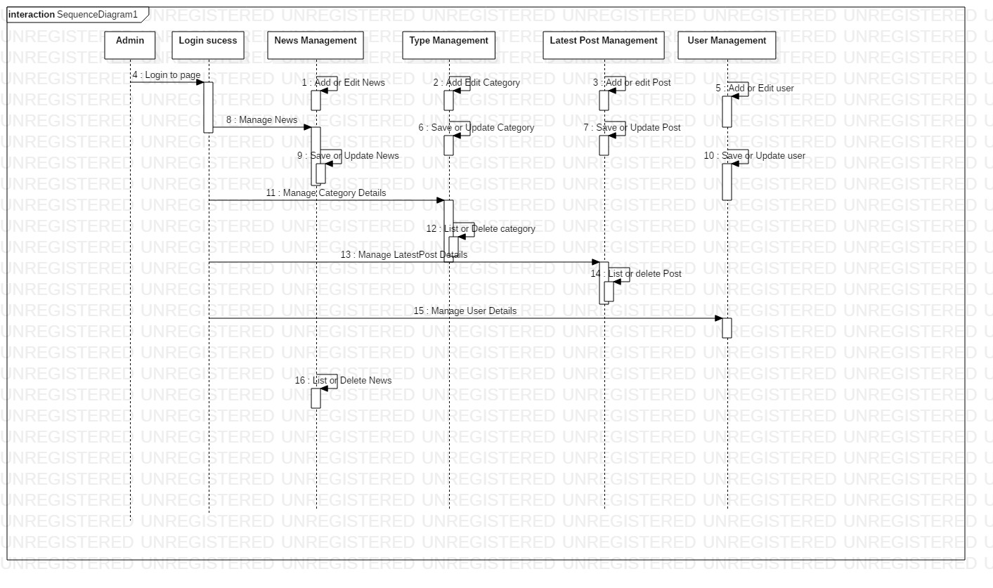

Figure :Sequence diagram

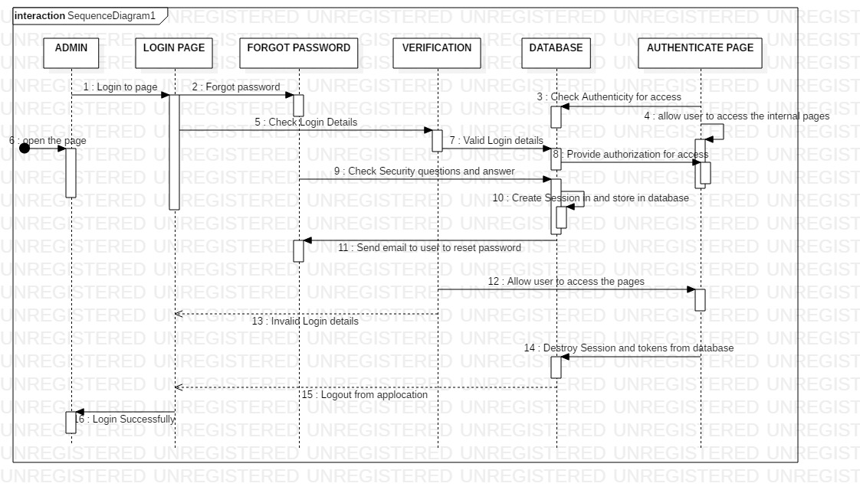

Figure :admin login sequence diagram..

## 3.2.3 DATABASE DESIGN.

Database is a collection of data in computer and should be accessible in various ways. Database is creating the database in a way that no errors or data is redundant. Database design is a part of system development life cycle. Here ER diagram is made after creating data dictionary.

## 3.2.3.1 DATA DICTIONARY.

Data dictionary is the set of data that is stored and includes metadata of database. The data about data is stored in data dictionary.

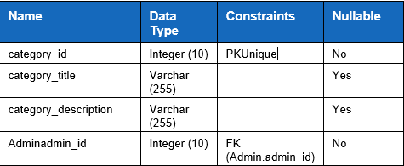

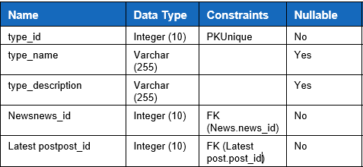

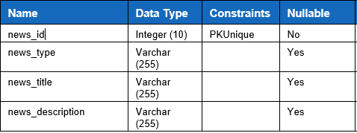

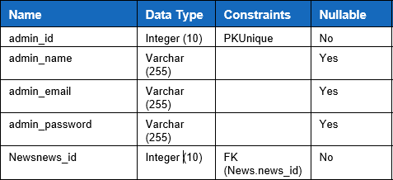

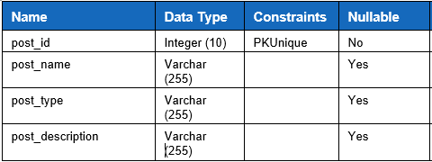

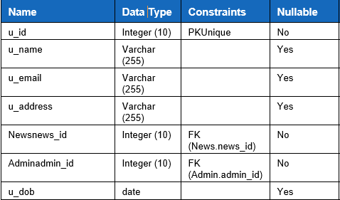

## 3.2.3.2 ER DIAGRAM.

ER diagram is the graphical representation of data dictionary. It shows the relationship between different entities.

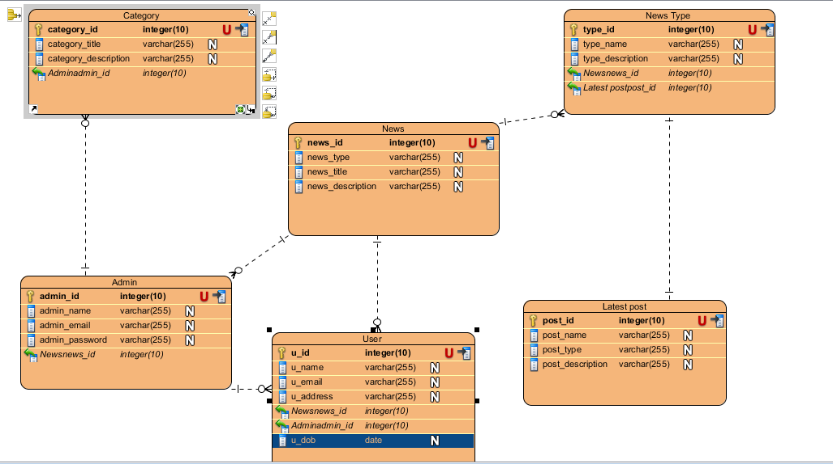

Figure :ER diagram.

## 3.2.4 UI DESIGN.

The UI design that we make should be interactive with user. First thing that a user wants is attractive and interactive design. User should be clearly able to recognize which button does what and the operations should be able to be used by customers.

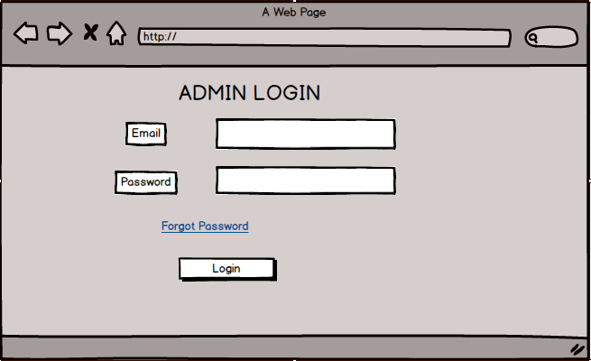

Figure :Admin prototype.

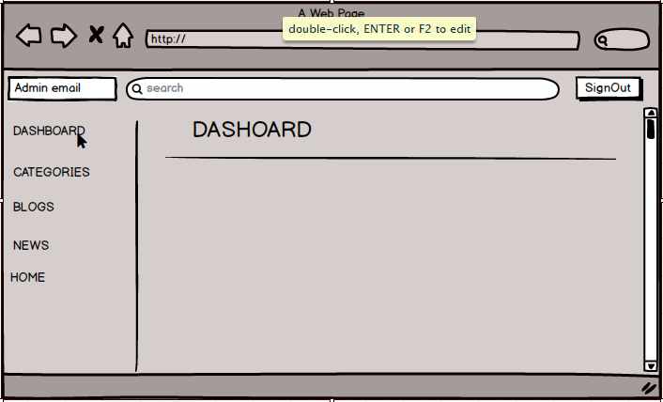

Figure : dashboard prototype

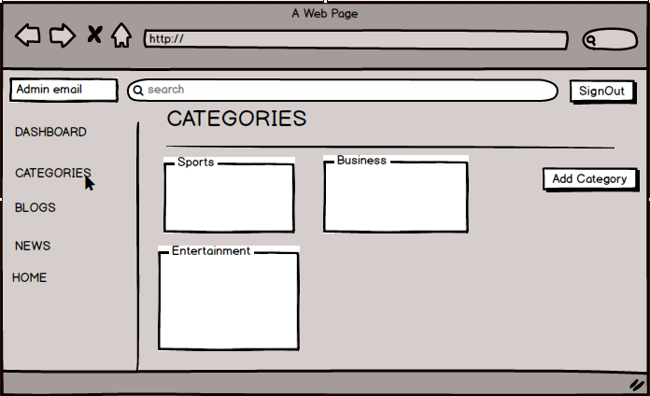

Figure :category UI

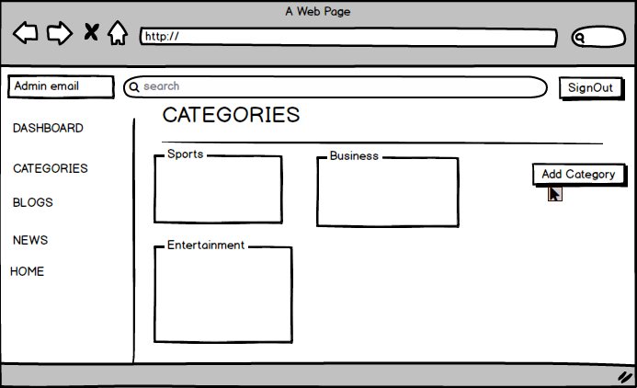

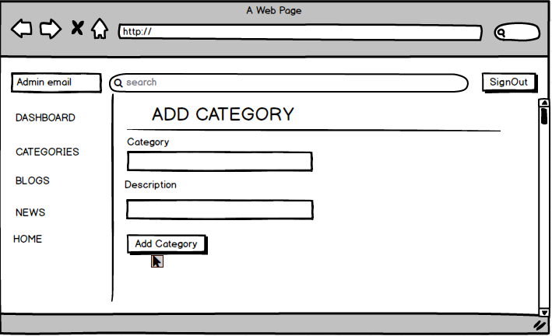

Figure :Add category UI

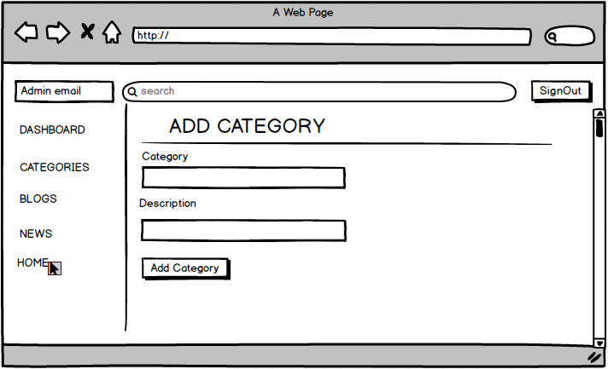

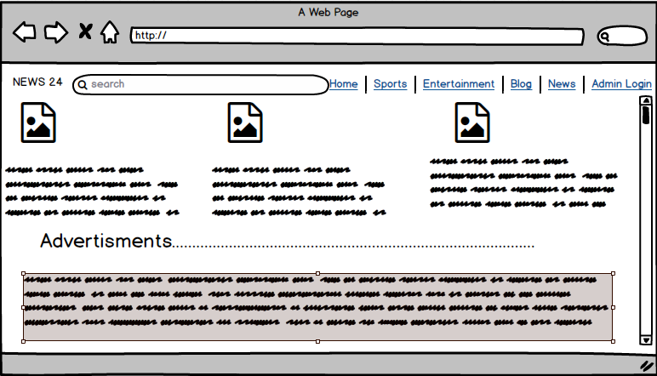

Figure :home page UI

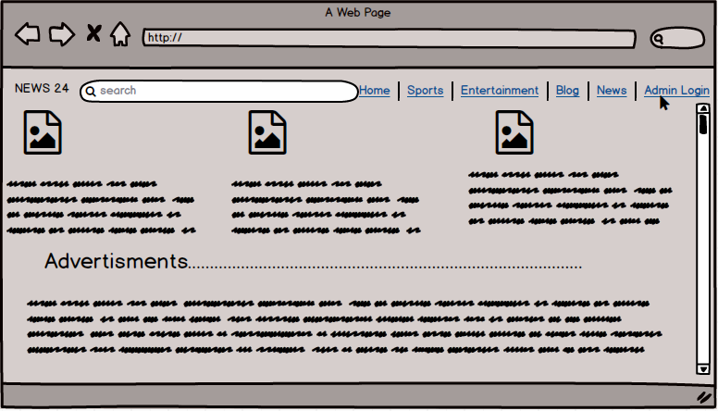

# CODING.

## 4.1 INTRODUCTION.

Coding is developing of the program by writing the program codes. To run a specific program, programing operation is generated with the help of coding interface. Coding makes the communication between the system and its user. According to the type of programming language, there are different syntax and operators for different programming language. These codes are the one that tells the system how to function. For a complex project to be made successful with fully functional program different strategies are made. Debugging and upgrading will be complex if the program is done without following any pattern. So, for a program to be easy to understand, good coding is necessary.

## 4.2 CODING METHODOLOGY.

Programming language have different types and among them I have chosen PHP for my project because, it is easy to learn and understand. For developing a dynamic website PHP is suitable because it is free to use and is an open source programming language. So, I have used PHP to develop this web application.

To manage the database most of the websites are using MYSQL nowadays because it is easy to use and is an open source. It is available for any kind of platform so that is why I have chosen MYSQL to manage the database of this web application. To manage the database various elements such as DDL (Data Definition Language), DML (Data Manipulation Language), DTL (Data Transaction Language) are provided to us and its performance and security is high. As well as I used XAMPP server that has Apache, MYSQL, Tomcat etc. Apache hosts the application locally.

For the coding part I have used Sublime Text as text editor. It is easy to use and is an open source software. It highlights the code and supports different programming language platforms. Also, this editor loads fast and is easy to use.

To run the code, I used Google Chrome as browser. I also used other browsers such as Mozilla Firefox, opera etc.

During coding I faced different problems and also resolved them. Some of them are:

* Multi user registration and login were time consuming.
* Front end part of the application was a bit complex so it a bit longer time.

# TESTING

## 5.1 Introduction.

Testing simply means the process of accessing features as well as functionality of the software. Testing can be called as a part in software development that consists of programming code and other documents. Testing helps in validation and verification of the software after we develop it.

In Software Development Life Cycle (SDLC), testing is an important phase. Testing comes when we finish the development of application by writing the code. Testing is done so that we can make sure that the system meets all the requirements that we specified in requirement phase before.

## 5.2 Importance of Testing.

Testing ensures the quality of product and quality product helps to gain the confidence of customers. Testing ensures the effective performance of the application. It can be expensive in future if there are any failure or the application doesn’t show result. Testing ensures the satisfaction and reliability of customer over the product. Users shall not be inclined to use the software that has pretty much bugs in it. So, testing is required to stay in a business.

## 5.3 Types of Testing.

To ensure that the application runs properly different test cases are run to ensure system performs as it is designed to. There are different types of testing and they are Blackbox Testing, Whitebox Testing, Unit Testing, Regression Testing etc. among all these testing, here I have performed two types of testing and they are Blackbox Testing and Unit Testing.

**Blackbox Testing.**

Blackbox testing is known as the high-level method of testing. In this testing only input and output are not seen by the users. Code, design, implementation etc. is not seen to the users.

Test name: Admin register.

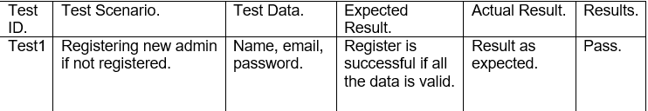

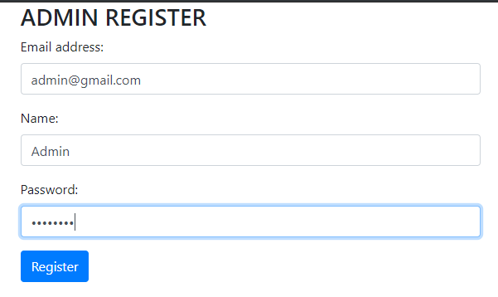

Figure :Test Admin register

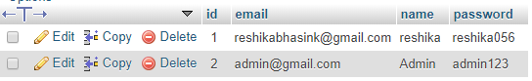

Test name: Admin login.

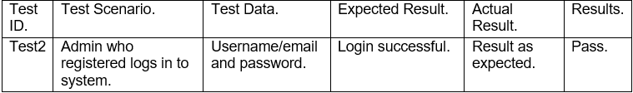

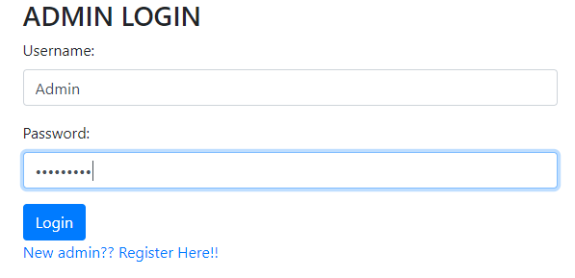

Figure :test login

Test name: Adding category.

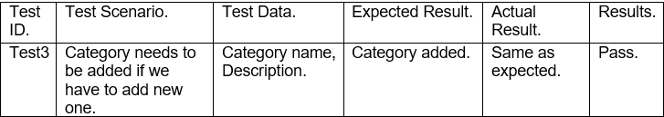

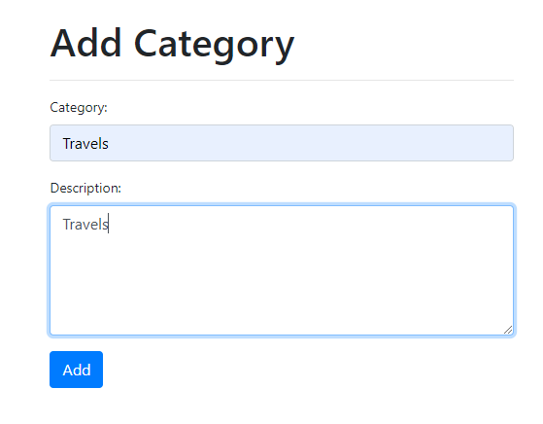

Figure :add category test

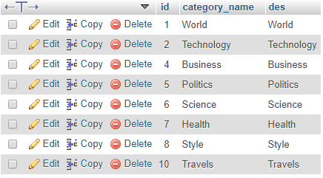

Test name: Delete Category.

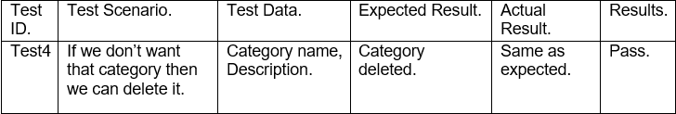

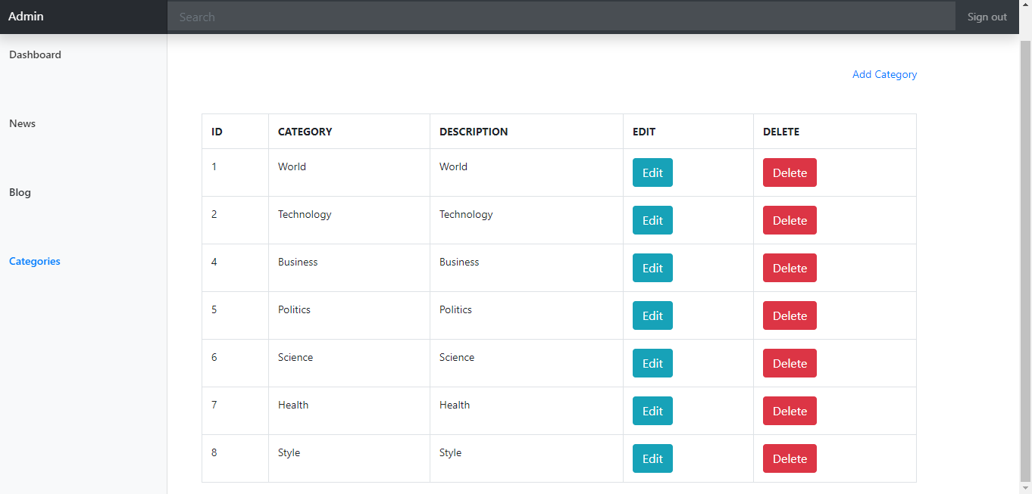

Figure :delete category test

Test name: Add News.

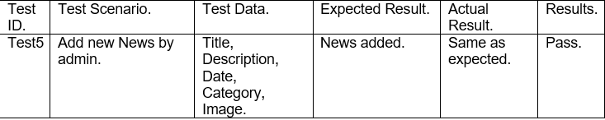

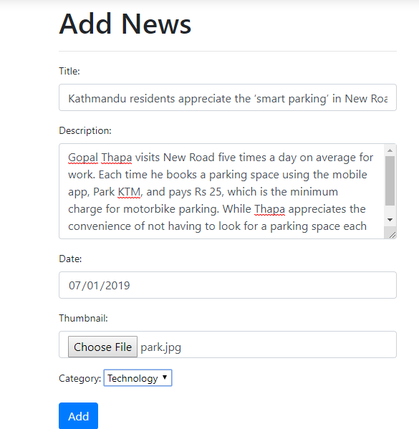

Figure :add news test

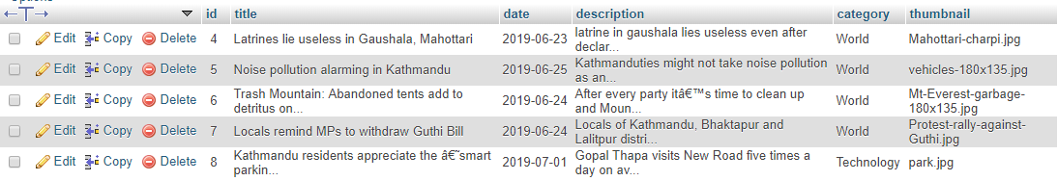

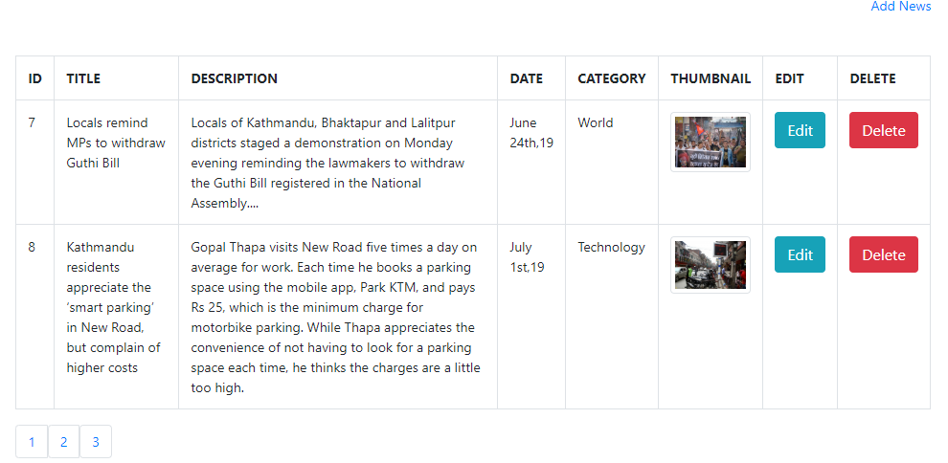

Test name: Delete News.

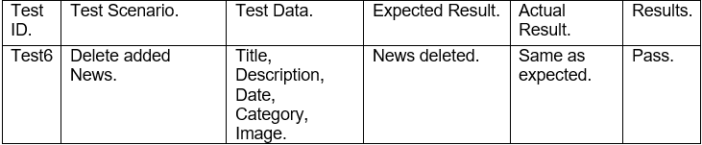

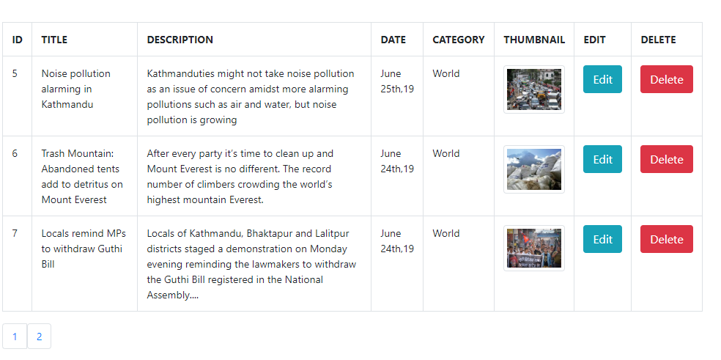

Figure :delete news test

Test name: Same email.

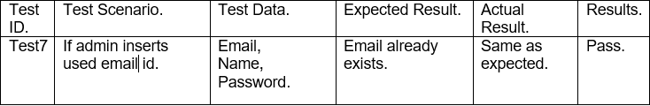

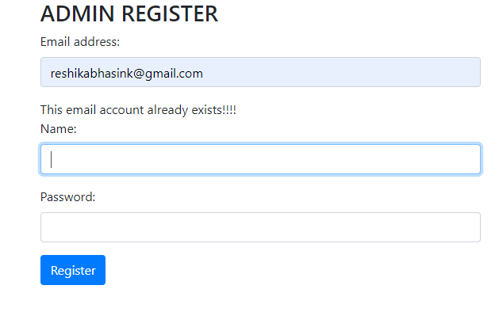

Figure :email validation test

Test name: Adding category that exists.

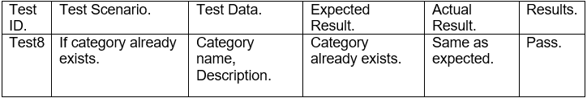

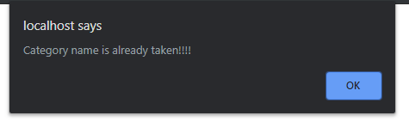

Test name: Logout.

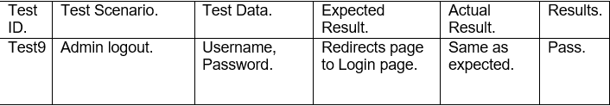

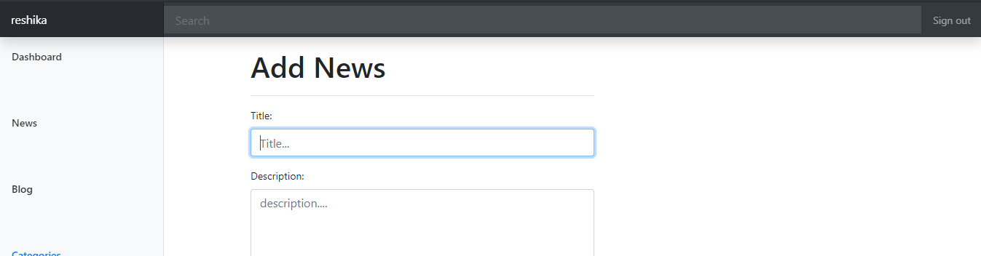

Figure :logging out from dashboard

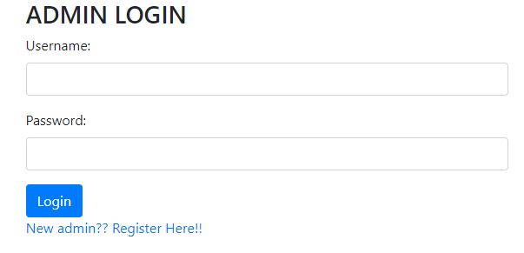

Test name: User profile update.

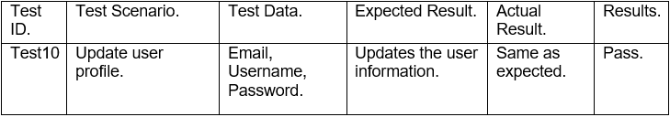

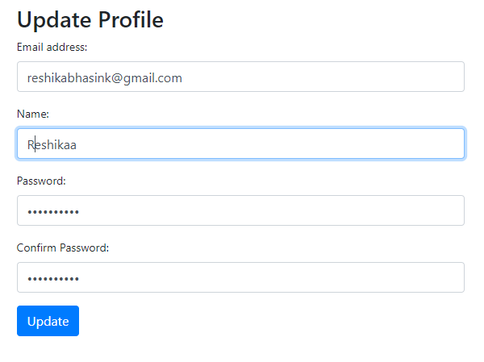

Figure :profile update

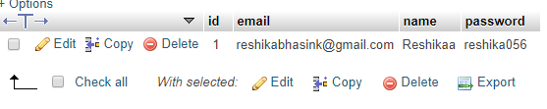

Unit Testing.

In unit testing, different functionalities of program are checked. This is done to make sure that every function performs as designed. By testing the code in this way, the code will be re-useable and reliable for the process of debugging. Some of the unit test that I have performed are given below:

Test name: Update.

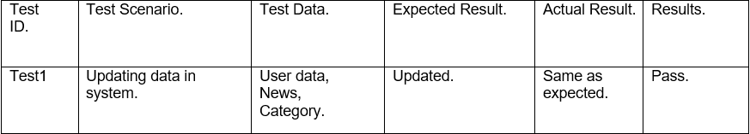

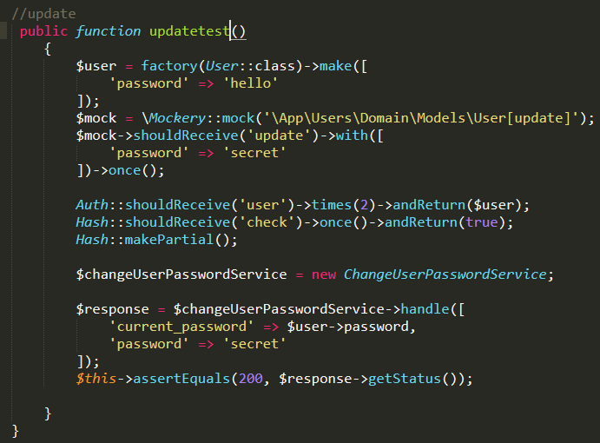

Figure :update test

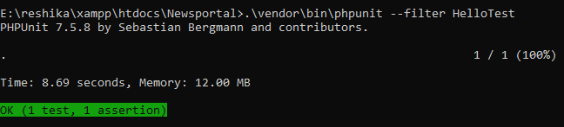

Test name: Login.

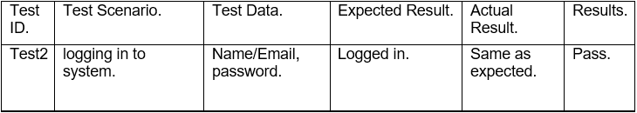

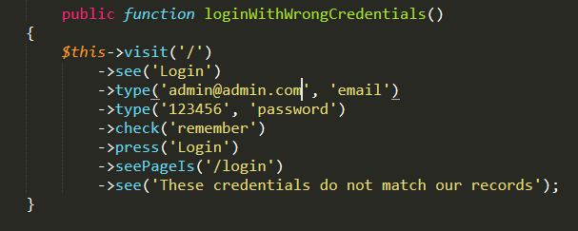

Figure :logintest

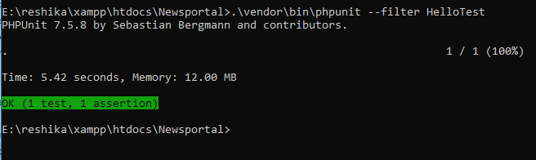

Test name: Register.

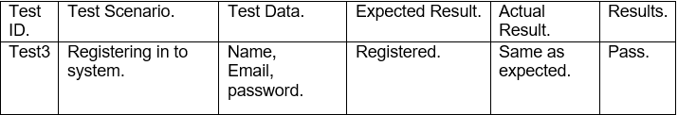

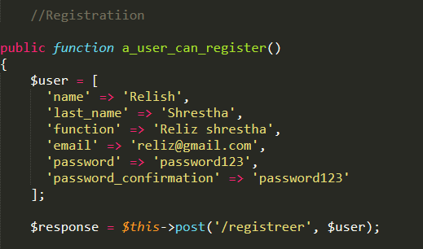

Figure :registration test

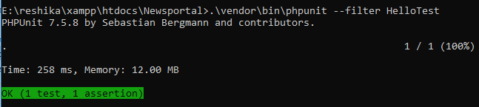

Test name: Delete.

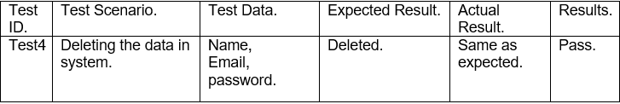

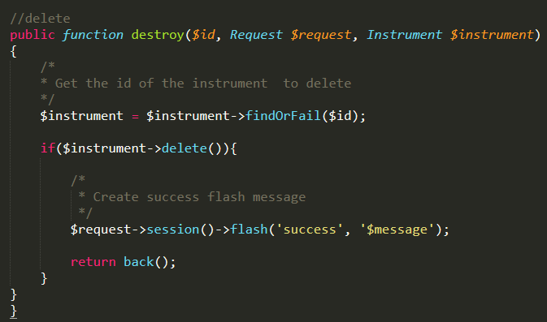

Figure :delete test

# OTHER PROJECT ISSUES.

Simply, project can be defined a task that is undertaken by an individual or group of individuals under certain time and budget. During the process of execution of project there may arise different problems and these problems can create issues in our project, also these problems can occur time to time. Certain plans should be made in order to handle these kinds of problem.

## 6.1 PROBLEMS DURING PROJECT.

I faced a lot of issues while creating this project. Some of main problems are given below:

* The changes that I made in CSS file was not loading and it showed failed to load changes. For this problem I had to search different websites for solution.
* The XAMPP server that I have been using was of older version. So, the apache server was not running and it was shutting down. I had to reinstall the XAMPP server.
* While uninstalling the XAMPP server, I forgot to take backup of the code that I have been doing, so all of the code got deleted as I uninstalled it. So, I had to redo all of it again.
* While coding an error of header already sent was shown that included session start failure. I had to restart the session.

## 6.2 LIMITATION OF THE PROJECT.

There are some limitations in the project that can be given a solution in future work and the limitations are:

* The application does not consist of sensibility level.
* Application’s searching system is not more flexible.
* News reporting system also could not be managed.
* The application could not support the communication system.

## 6.3 RISK MANAGEMENT.

Risk management means identifying the factors of risk in a project. There may arise various risk in our system and that should be minimized as soon as possible.

Risk Likelihood.

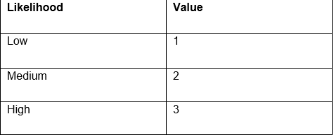

Risk Consequences.

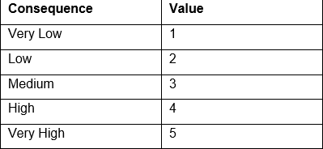

We can calculate the impact by a formula and that is

[*Impact = Likelihood * Consequence*]

Risk Management Table.

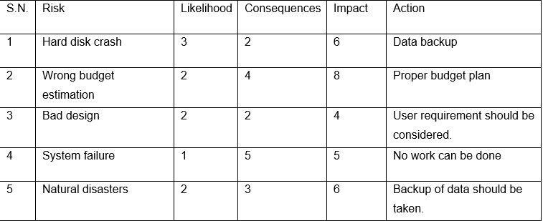

## 6.4 CONFIGURATION MANAGEMENT.

This is the process of maintaining and establishing consistency in product performance. Configuration management can be used by management and engineers to see what has been changed and why. This process keeps the track of change in a project. Configuration management helps to keep check on reliability and ensures that change in one part does not affect the other.

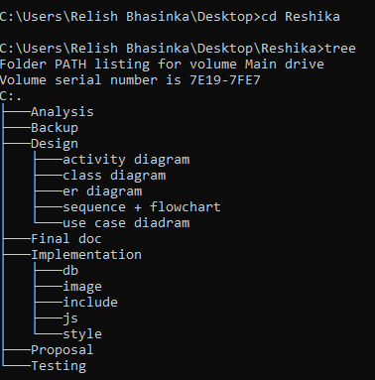

Figure :configuration of folders

## 6.5 FUTURE WORK.

Future work are the tasks that can be done in future so that our project becomes more advanced by adding extra features to increase the functionality. The features that we are not able to include because of short time duration will be included. We will develop a large volume website in future if we get a chance in future. For other future developments in website following can be done.

* Database shall be updated.
* News reporting system will be managed.
* Video conferencing system will be managed.
* Searching area can be made more flexible.

# CONCLUSION.

The project was completed as per the requirement and functionality within the time. The web application that I developed i.e. ’Online News Portal’ consist of functionality such as user, admin, category, news etc. The functionalities will be allocated as admin logs in to system. the main aim of this project is to make less waste as people have to buy newspaper to know about news and this also consumes less time.

In this project I have used PHP, MYSQL, JAVASCRIPT, BOOTSTRAP etc. at the first stage analysis was done to gather the requirements. For analysis, questionnaires and interviews were done. Then prioritization off requirements was done to identify which one was most important and which one was least. Different diagrams were drawn such as ER diagram, Class diagram, Activity diagrams were drawn so that it would be easy to understand. Then coding was done as per design. For coding database was designed and connection was established. After finishing to code, testing was done. I chose Unit testing and Blackbox testing. During the project, various issues were faced and resolved with the help of tutorial and references.

In this way, project was completed according to requirement and functionalities and all the task were completed on time.

# CODE APPENDIX.

* Header.

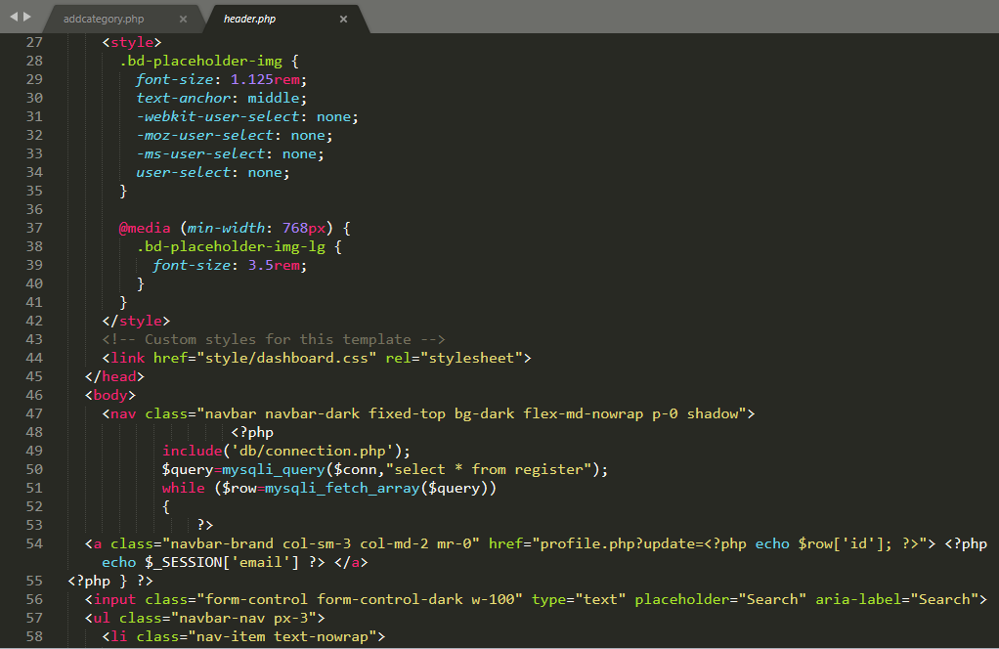

Figure :header code.

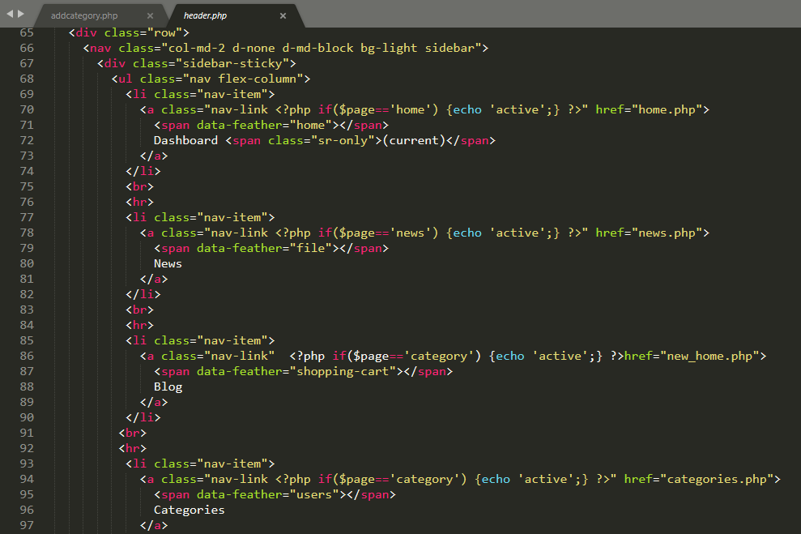

* Footer.

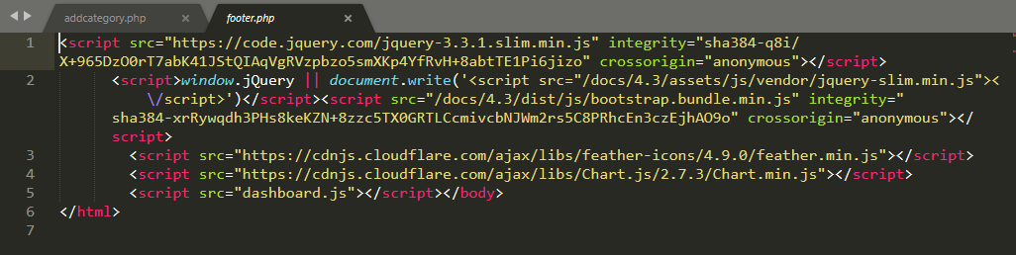

Figure :footer code,

* News.

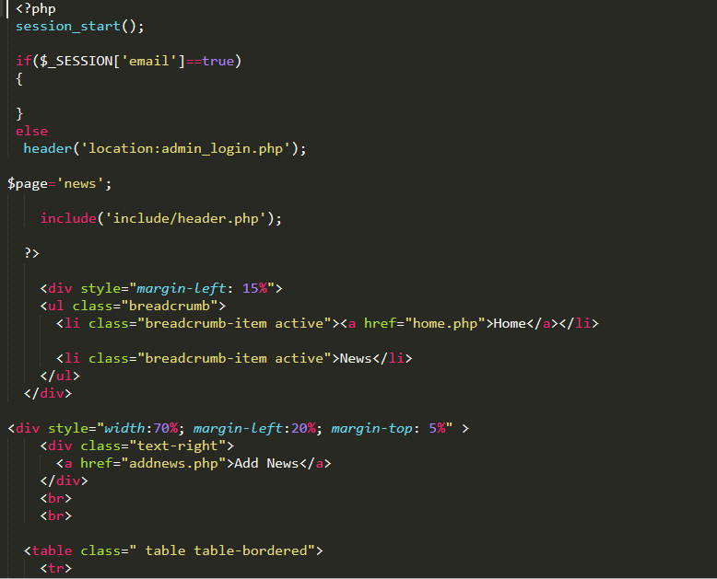

Figure :News code.

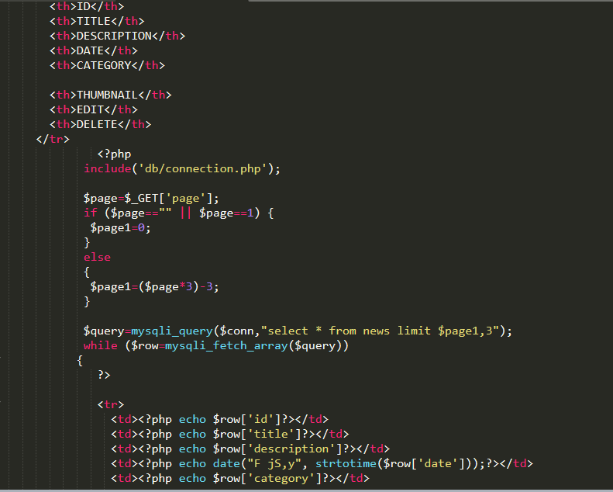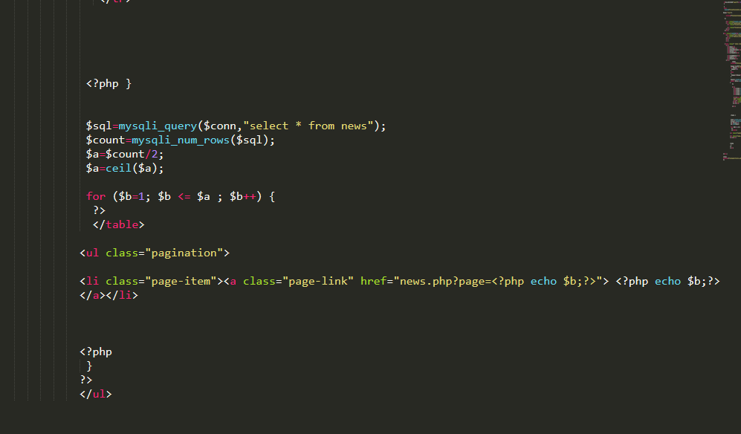

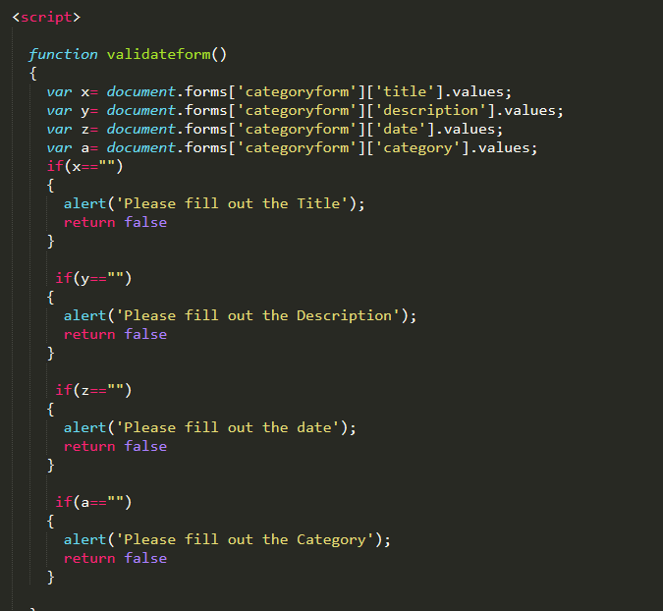

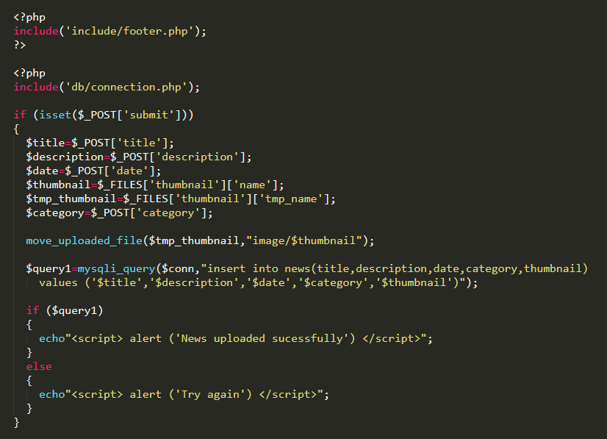

* Admin.

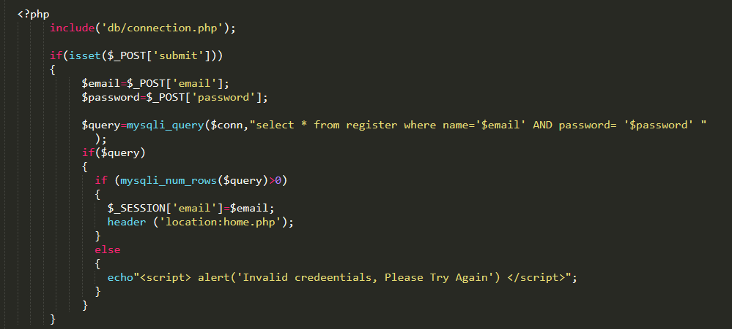

Figure :admin login code.

* Category.

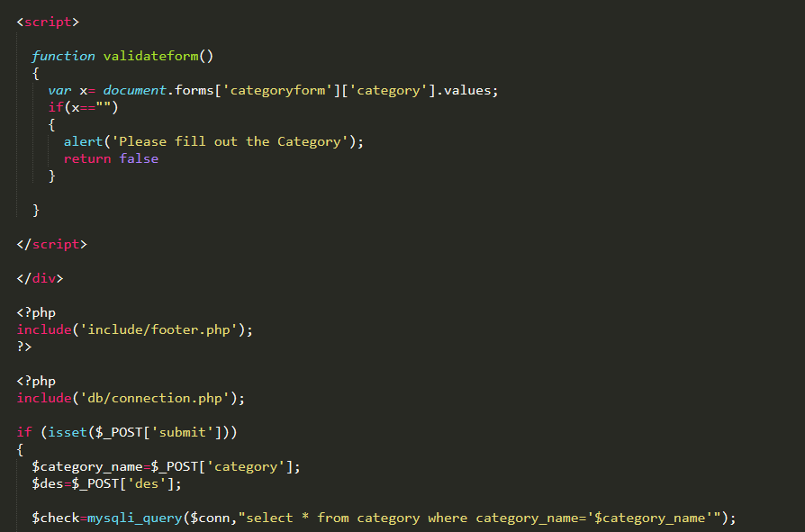

Figure :category code.

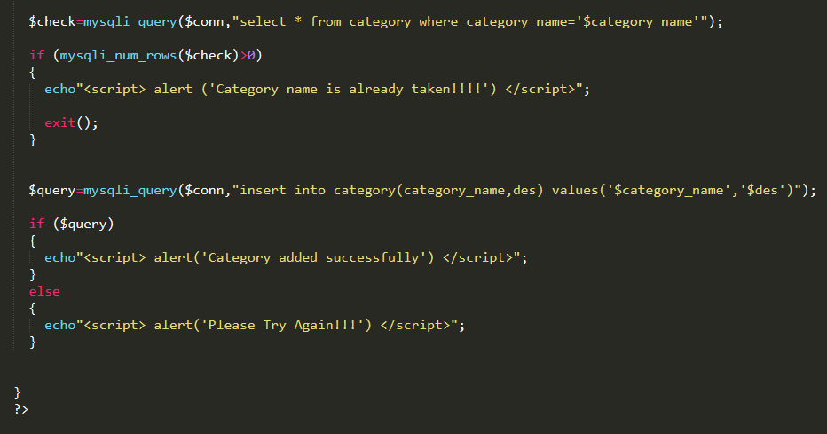

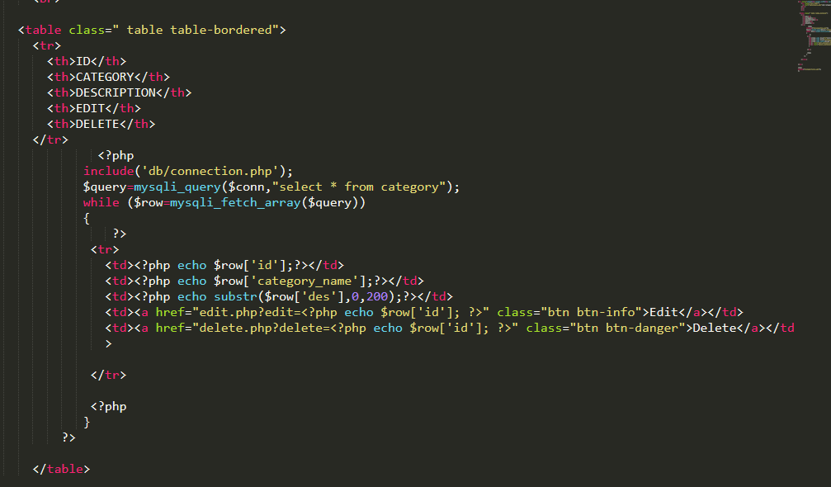

* Dashboard.

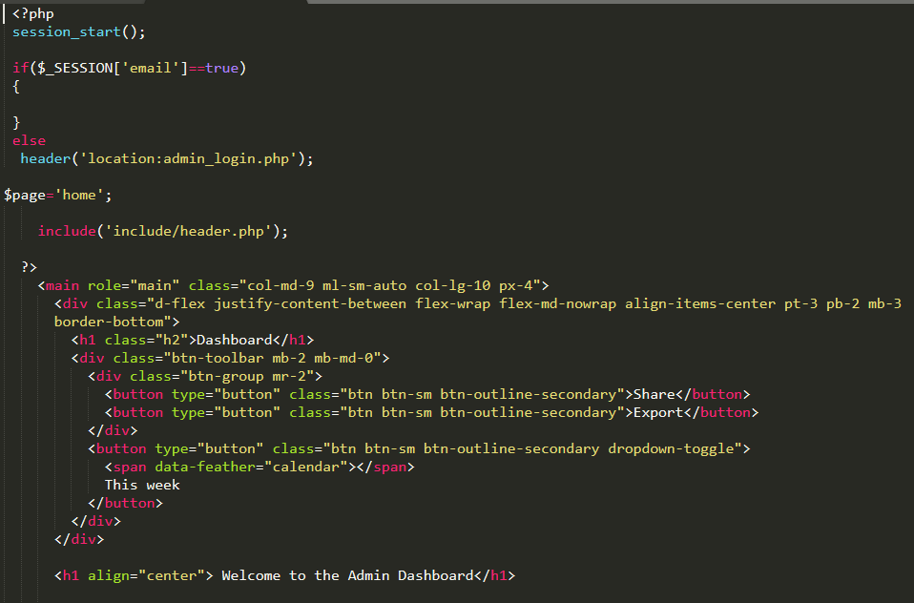

Figure :dashboard code.

* Database.

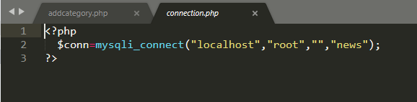

Figure :database connection.

* Sign out.

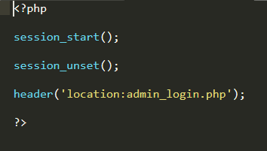

Figure :logout code.

* Profile.

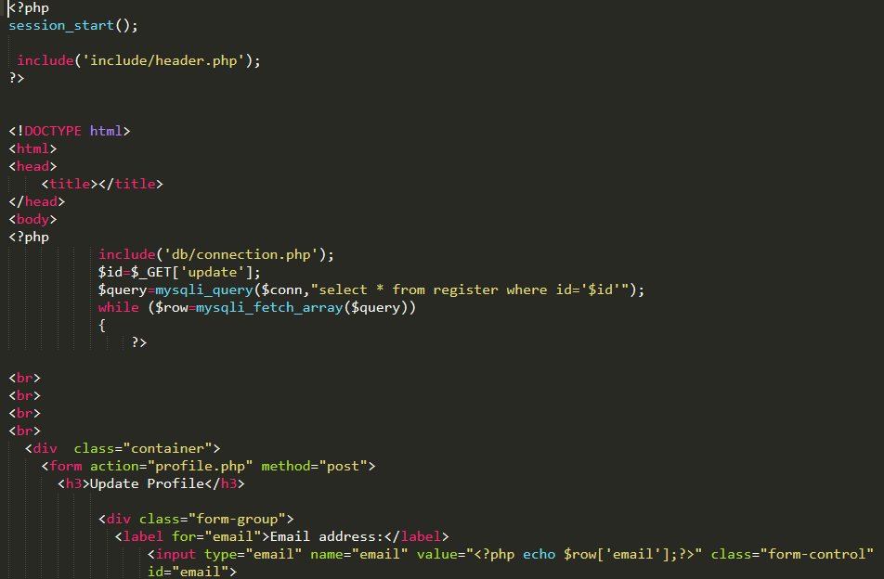

Figure :profile update code.

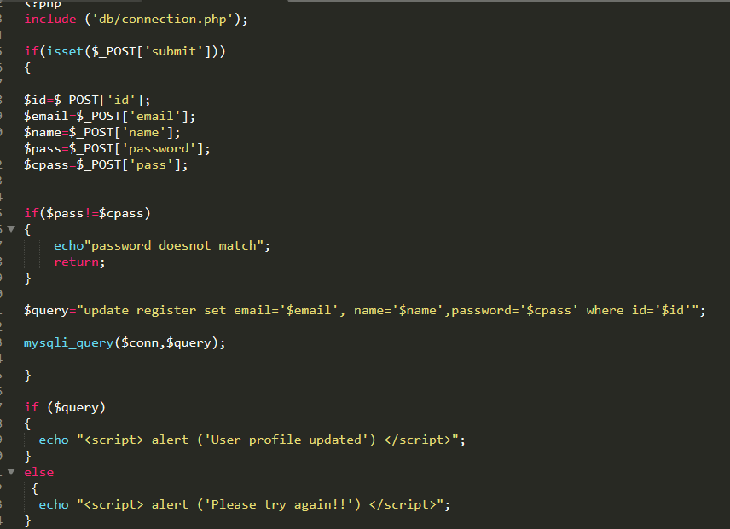

* Register.

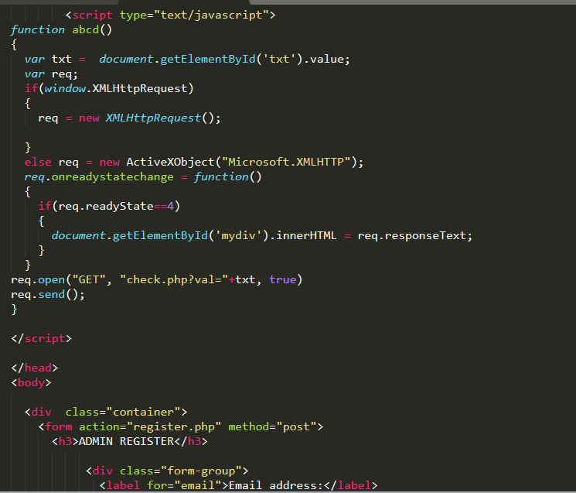

Figure :Register user code.

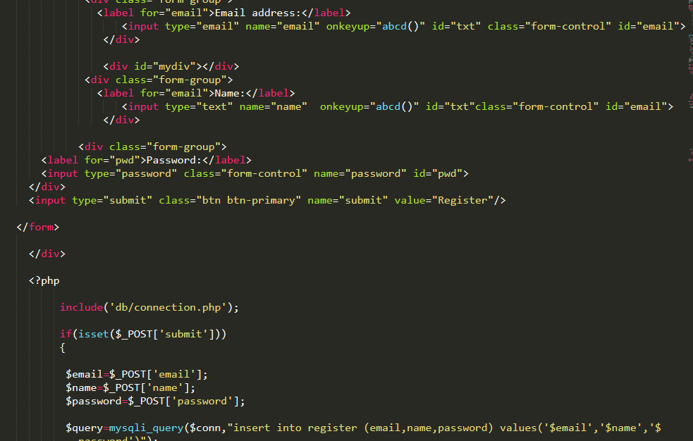

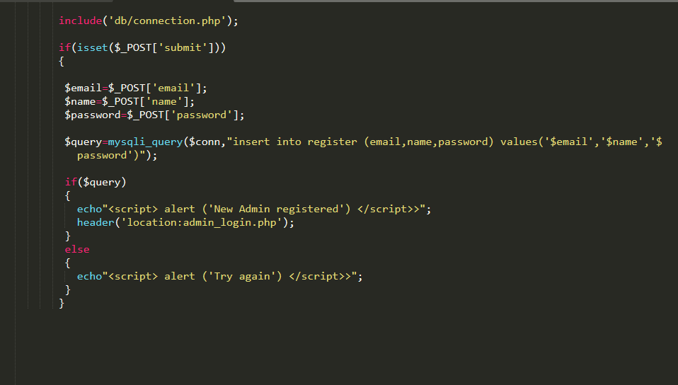

* Home.

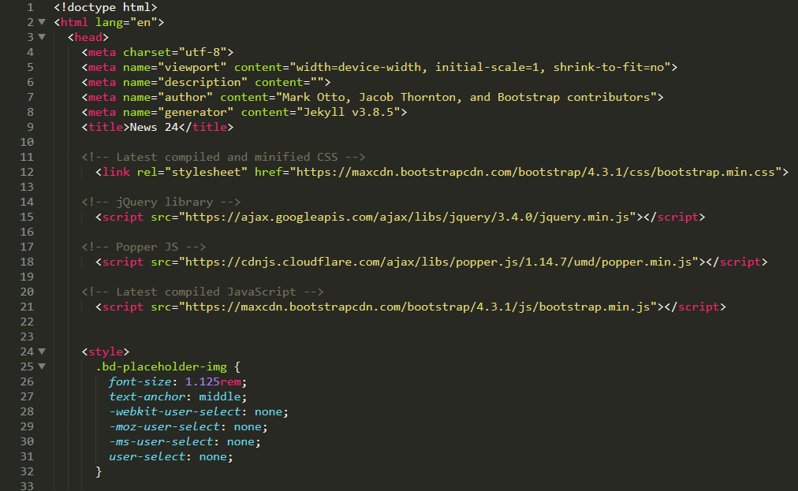

Figure :Home page code.

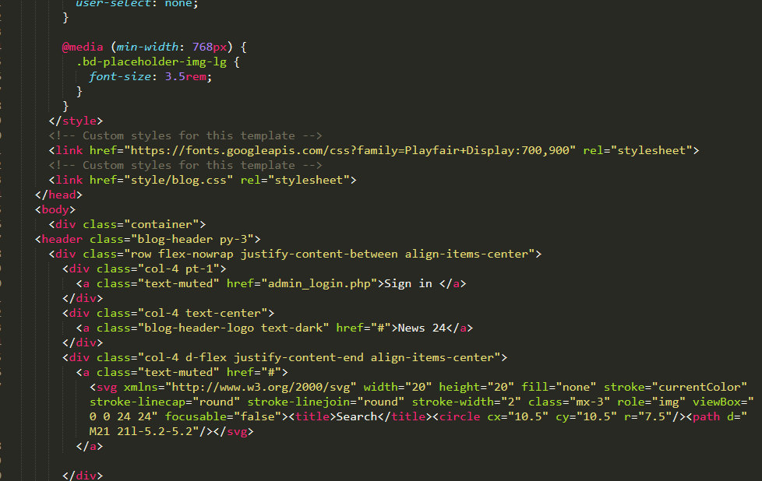

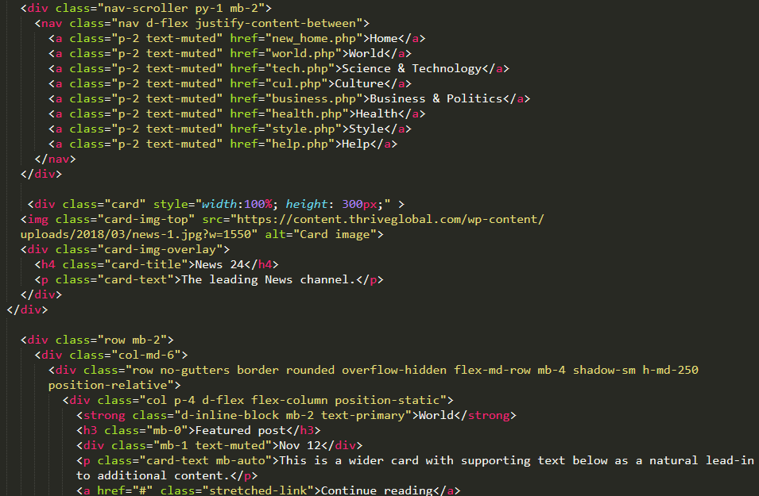

# USER MANUAL.

Some users would not be able to use the software so, there is a need of user manual in every software project. What user manual does is, helps or guides the user to use the software. For my Online News Portal, I have created the following user manual.

1. Admin Login.

After admin opens the news portal login form opens up.

Then enter login data.

Click on login.

If you are new then click on register.



Figure :Admin login.

1. Adding News after opening dashboard.

After login dashboard opens.

Click on news option.

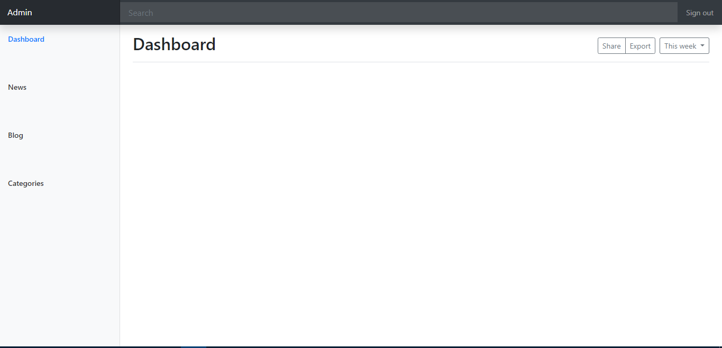

Then news page opens up and click on add news option.



Then a form opens up and add the news details.

Then click on add.



Figure :News addition.

1. Add Category.

After dashboard opens click on category.



Then category page opens up and click on add category.



The add category page opens.

Now insert category details and click add.



Figure :Category addition.

1. Edit Category.

As we opened category page.  
Click on Edit.



Figure :edit category.

1. Delete category.

Click in delete option.



Figure :delete category.

1. Edit news.

As we open news page.

Click on Edit option.



Figure :Edit News.

1. Delete News.

Click on Delete option.



Figure : delete news.

1. Update User profile.

After opening dashboard, open up you profile.



Then user profile page opens up and then fill updating details.

Click on update.



Figure :update user profile.

1. Logout.

Click on the right side of dashboard to logout.



Figure :Logout.